**GOVERNMENT COLLEGE OF ENGINEERING [IRTT]**

**ERODE: 638 316**



**Electronics and Communication Engineering**

**NAAN MUDHALVAN**

**DIGITAL MARKETING**

**ASSIGNMENT**

NM ID: 4EB12F7E56833D7BB1A4BD36B35AE8DB

NAME:DHARANITHARAN M

*BRAND NAME: SIP & SAP*

*CATEGORY: FRUIT JUICE*

1. Create a blog or website using Blogspot and WordPress. Customize the theme design and post new article with 500 words.

Link: Blog using Blogspot

<https://sipandsap.blogspot.com/>

Screenshot:

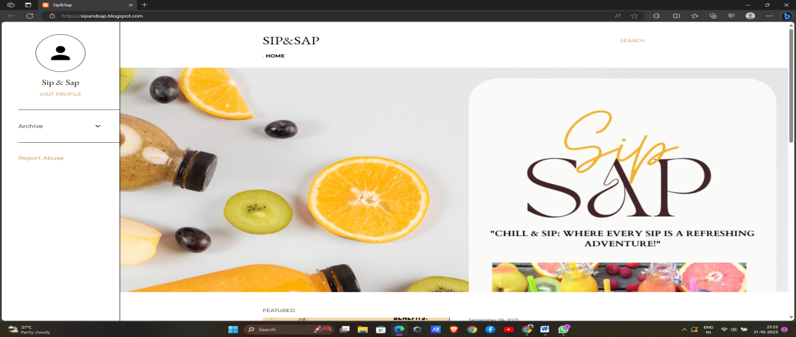

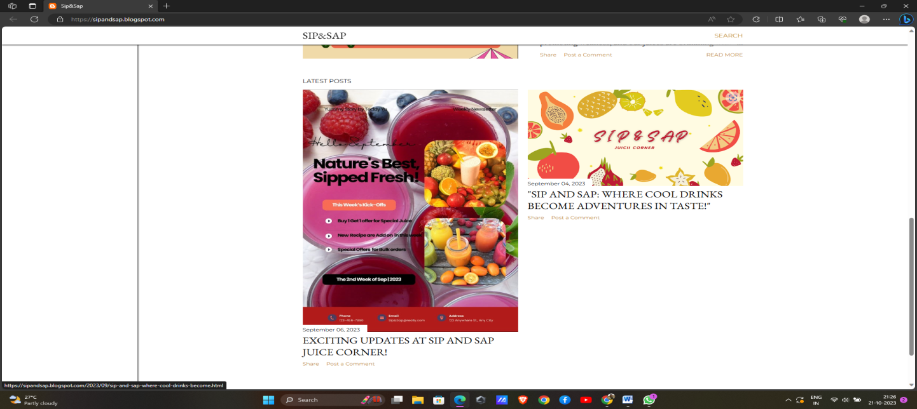

2.Create a New Facebook Business Page and post one social media poster for your brand.

Link: Facebook business page

<https://www.facebook.com/profile.php?id=61550695902844>

Screen shot:

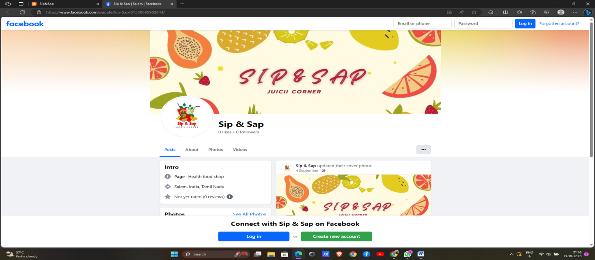

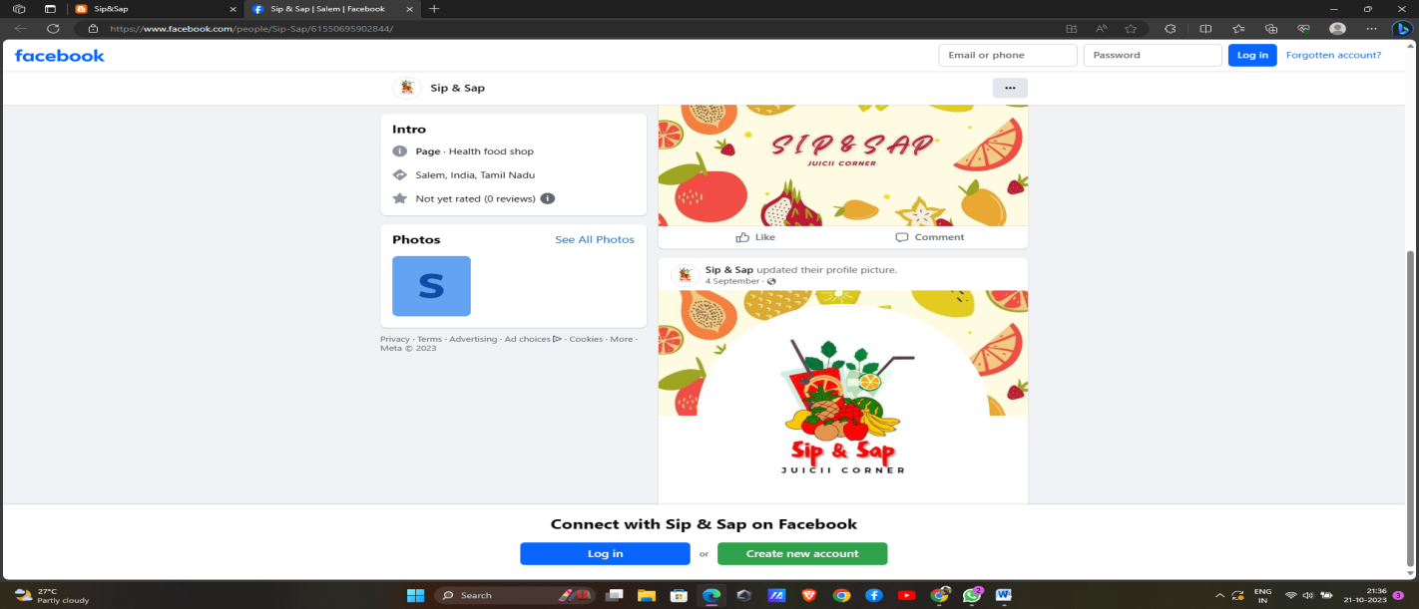

3.Create and design a social media advertisement poster using canva.

Link:

<https://sipandsap.blogspot.com/2023/09/exciting-updates-at-sip-and-sap-juice.html>

Screenshot: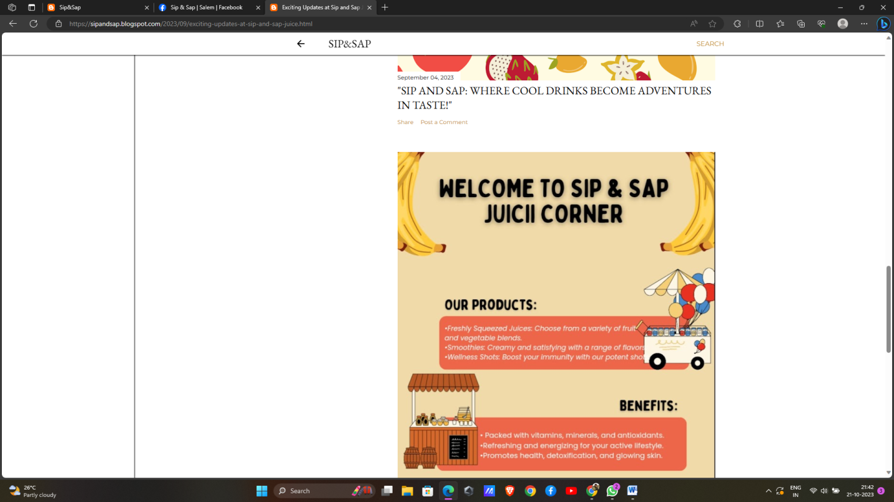

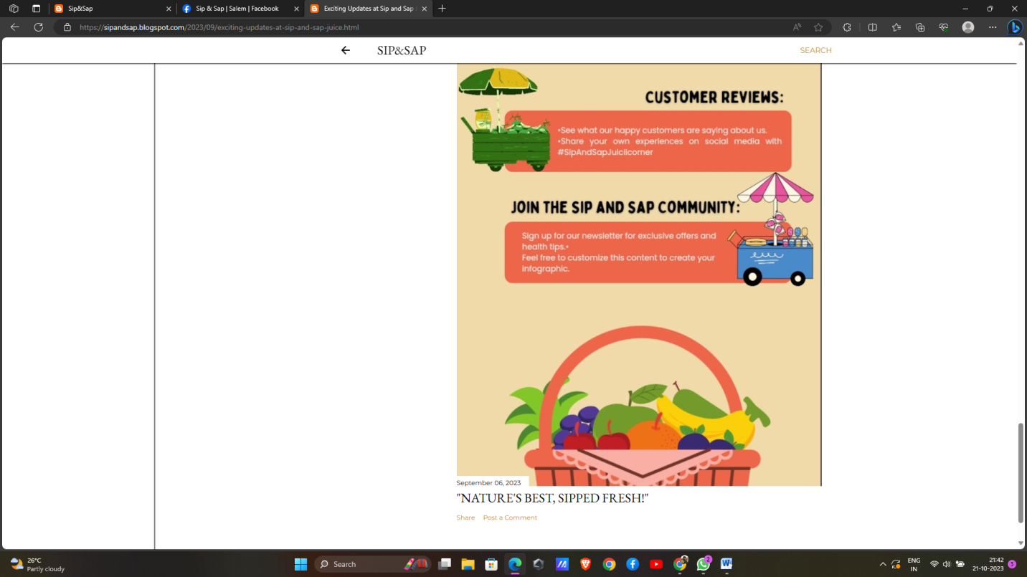

4.Create email newsletter design using MailChimp or canva tool.

Link: Email newsletter design using canva

<https://sipandsap.blogspot.com/2023/09/natures-best-sipped-fresh_6.html>

screen shot:

